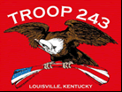
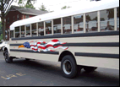
TROOP 243
December 1st, 2015
Boy Scouts of America
Chartered by St. Barnabas Catholic Church

3044 Hikes Lane Louisville, Ky 40220
http://www.troop243.com

Troop 243 Outings & Activities – As we start December looking at inventions, we will also sponsor a AED/First Aid merit badge class for non-certified adults and scouts needing the merit badge. In preparation for an active camping season starting in January, we will also spend time preparing out patrol boxes. Our last troop activity will be our annual Troop 243 lock-in/dodge ball grudge match. The always-confident adult leaders continue to promise not to be too hard on the dainty scouts.

Troop and Patrol Meetings on Wednesdays - All are welcome. Scouts in Field/Class A uniforms are expected for all troop meetings while class B uniforms are ok for patrol meetings. Except where noted, all meetings are held at St. Barnabas. SERVICE PATROLS should arrive 15 minutes early to set up for the meeting.

December 2nd, 7:00 PM – Troop Meeting @ Inventing – The service patrol is Combat Spartans
December 9th, 7:00 PM – Patrol Meetings – Patrol Box Prep - No Service Patrol
December 16th, 7:00 PM – Troop Meeting @ Inventing – The service patrol is Danger
December 23rd, - No Meeting
December 30th, - No Meeting

AED/First Aid Merit Badge Class - December 5th, we will host a First Aid/AED merit badge class from 9:00AM to 5:00PM. We are inviting adults who have not had CPR and scouts who do not have the First Aid Merit badge. We have to have a solid count on the participants. To that end, please reply to this email or send me a separate email so I can get a count. RSVPS must be received no later than December 2nd. Notice that this is an all day class so be sure to bring a lunch, drink and any other snack type thing you may need to get you through the day. Do not count on there being a fridge in which to keep your lunch.

Christmas Lock-in - Don’t forget to add to your home calendar December 18th, which is our annual troop lock-in. While details may change, the doors generally open at 6:00PM and close shortly there after. Late admission has to be arranged ahead of time. All scouts must be picked up by 8:00 AM Saturday morning. Your leaders want to get home also and have to wait if you are late. Please do not be late. Everyone is asked to bring a treat without Peanuts to share with the troop. We also need adult volunteers to help. You do not have to be a registered leader.

Scouting for Food - Scouting for Food results: Troop 243 and Pack 756 collected 2596 non-perishable food items and donated them to the SEAM food bank on Klondike Lane. This is combined with the other troops. Do the math yourself to see how many families will have healthy, safe and tasty meals. Children will study better, adults will work better to get out of their situation and Jesus who lives in these people was helped many times today. Congratulations and thanks to all!

Troop Leadership Meetings – There are no scout or adult leadership meetings in December.

Was there some fun in January? Yeeees. I will include here the words of Mr. Early.
“Even though I am sure that someday people will sing folk songs about the mighty deeds of Troop 243 I wanted to make sure these guys were recognized. At Klondike Derby in January we came in first place in 3 of the ten completions. Overall time we came in third of 21 patrols. We made two patrols from our existing ones. The youngest guys in the Blitzkrieg Patrol boiled water in a pot and a fire started without matches in 1 minute 34 seconds as well as being the only group to identify and treat hypothermia in their scenario. They came in 6th overall of 21 patrols. The other patrol (the Vampire Teddy Bears) won two of the ten events with the “Camp Confusion” scenario and the Knots competition. It was a great weekend and the guys are looking forward to doing even better next year. The adults enjoyed an amazing meal prepared by Mr. Hamilton and stayed warm in the cabin with the help of Mr. Botner’s fire stoking expertise. Additionally as an impartial observer (kind of) it seems like the emphasis on Scout Skills during the Administration of Kenneth Botner, SPL, really paid off. Congrats again guys!”

FUN!

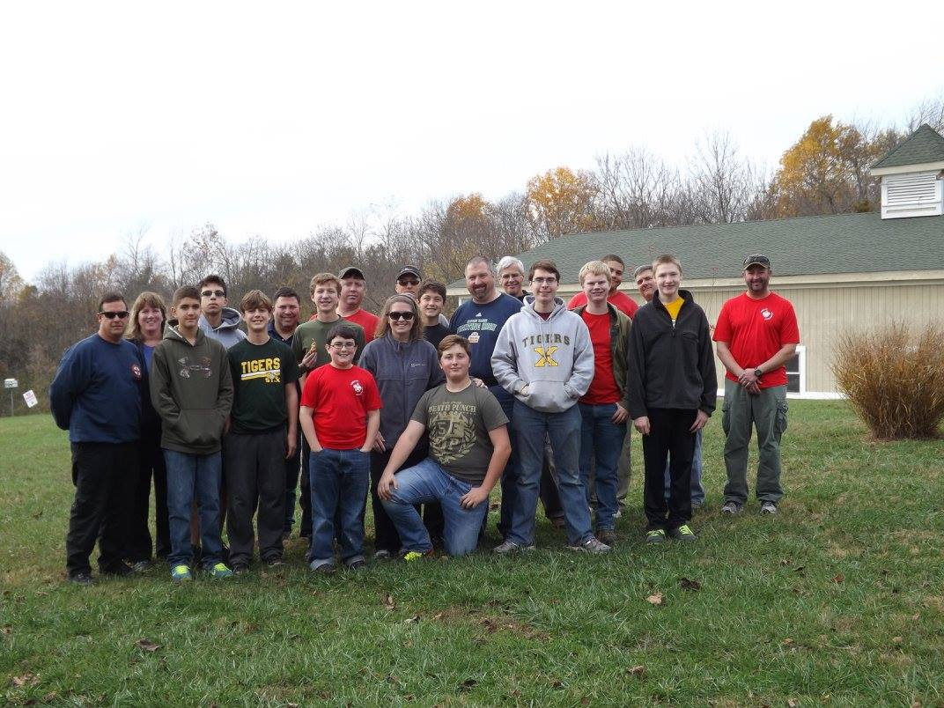
In October our scouts participated in a program called the Young Eagles project. These scouts were taken up in a plane by an experienced pilot and after some instructions were allowed to take control of the plane while in the air. It is quite an experience and just might kindle some interest in careers as pilots.

November’s fun included the completion of Nick Craven’s Eagle Project at Creasy Mahan Nature Preserve and Jonathan Stuecker earning Eagle Rank! Everybody congratulated Jonathan at our most recent troop Court of Honor and we look forward to celebrating his amazing achievement at his Eagle Court of Honor.



